**COEN 166 Artificial Intelligence**

**Homework #3**

Guideline: Please complete the following problems and submit the answers as a single PDF file to Camino. If the homework is hand-written and scanned, please make sure the handwriting is discernable, otherwise credits may be deducted.

**Problem 1**: Consider the following game tree in which the utility values (in parentheses at the leaf nodes) are all from the first player’s point of view. Assume that the first player is the maximizing player.

Figure 1.1

a. What leaf nodes (nodes at the bottom layer) would not need be examined using the alpha-beta pruning algorithm – assuming that the nodes are examined in left-to-right order? Show the derivation procedure on the graph.

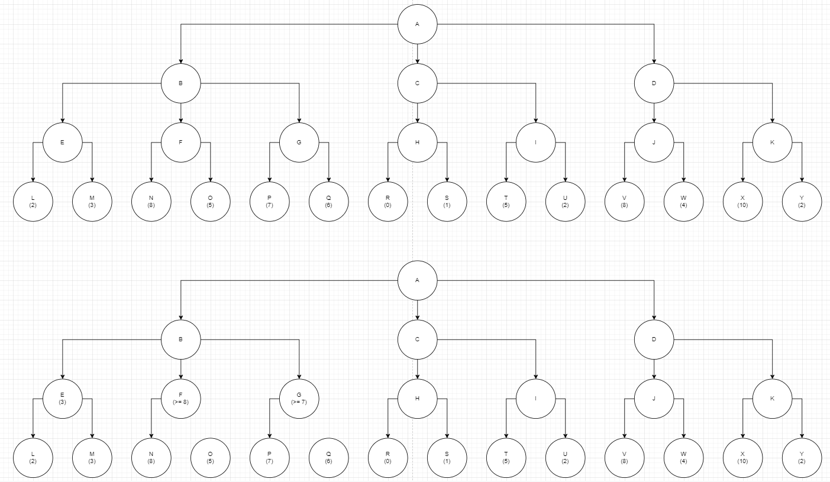

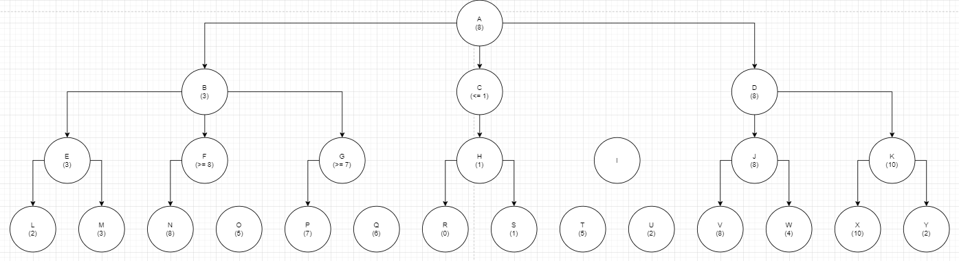

The leaf nodes of O, Q, T, U do not need to be examined.

b. What move should the first player (the root node) choose?

The first player should choose D as the first move.

c. What’s the final minimax value of the root node?

The final minimax value of the root node is 8.

**Problem 2**: Consider the following search tree.

Figure 2.1

a. Fill in the squares and circles with the backed-up values resulting from a regular minimax search.

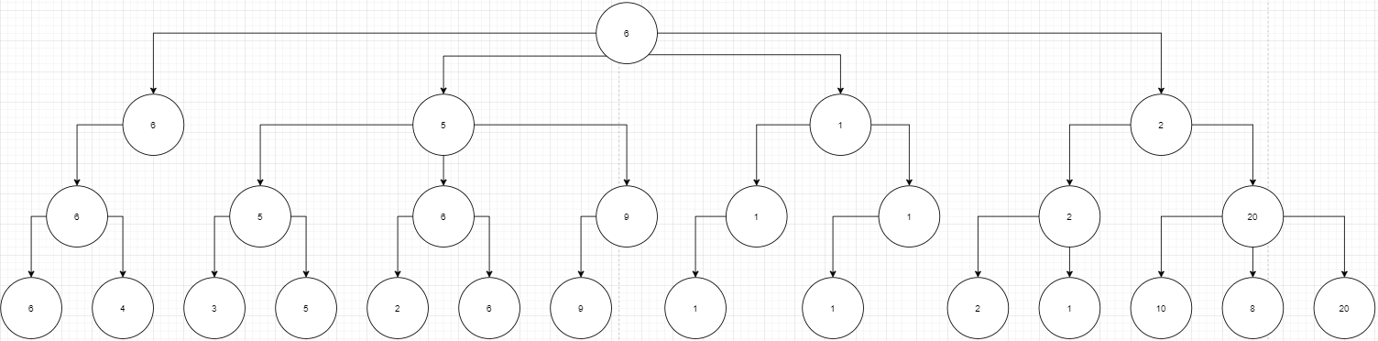

b. What leaf nodes (nodes at the bottom layer) would not need be examined using the alpha-beta pruning algorithm - assuming that the nodes are examined in left-to-right order? Show the derivation procedure on the graph.

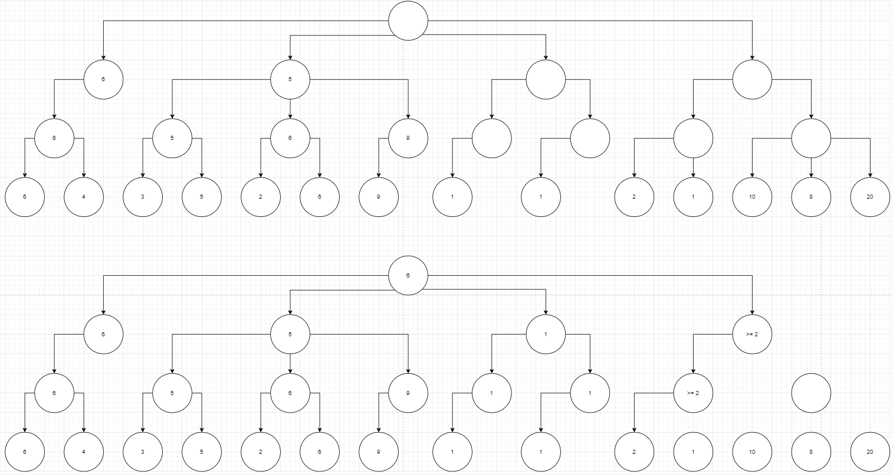

The last four leaf nodes at the bottom do not need to be examined.

Figure 2.1

c. What is the minimax value of the root node?

The minimax value is 6 for both procedures

**Problem 3** Consider the game tree below, where the terminal values are the payoffs of the game. Fill in the expectimax value of each node, assuming that player 1 is maximizing expected payoff and player 2 plays uniformly at random (i.e., each action available has equal probability).

a. What is Player 1’s expected payoff if she takes the expectimax optimal action?

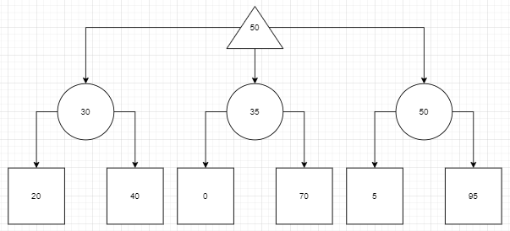

She will get an expected payoff of 50.

b. Multiple outcomes are possible from Player 1’s expectimax play. What is the worst possible payoff she could see from that action?

The worst possible payoff is 5.

c. Even if the average outcome is good, Player 1 doesn’t like that very bad outcomes are possible. Therefore, rather than purely maximizing expected payoff using expectimax, Player 1 chooses to perform a modified search. In particular, she only considers actions whose worst-case outcome is 10 or better.

c.1 Which action does Player 1 choose for this tree?

She will choose the first action (leftmost), since it is the only action with a worst case outcome that is greater than 10 (it has outcome 20).

c.2 What is the expected payoff for that action?

The expected payoff is 30 for that action.

c.3 What is the worst payoff possible for that action?

The worst payoff possible for that action is 20.

**Problem 4** This question considers pruning in games with chance nodes. Figure 5.19 shows the complete game tree for a trivial game. Assume that the leaf nodes are to be evaluated in left-to-right order, and that before a leaf node is evaluated, we know nothing about its value - the range of possible values is −∞ to +∞.

a. Copy the figure, mark the value of all the internal nodes, and indicate the best move at the root with an arrow.

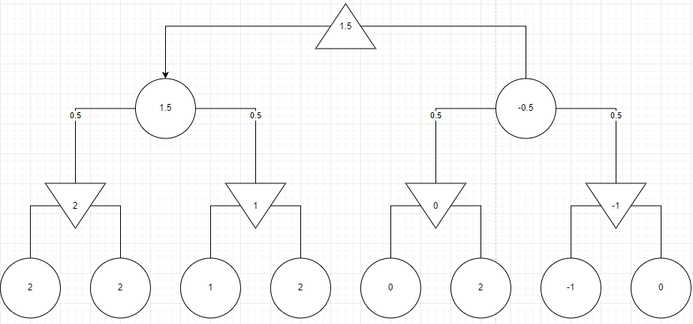

The best action at the root is the leftmost action.

b. Given the values of the first six leaves, do we need to evaluate the seventh and eighth leaves?

Given the values of the first seven leaves, do we need to evaluate the eighth leaf? Explain your

answers.

Yes, we need to evaluate the seventh and eighth leaves because we are trying to maximize the value at the end. Depending on the seventh and eighth leaves on the right, if it was a large value, we could surpass the expected minimax chance value on the left when calculating the expected minimax chance value on the right, trumping its significance to the calculation.

For the second scenario, we still do need to evaluate the eighth leaf because it can change the whole landscape of what could be the final minimax value. The seventh leaf is less than the expected minimax chance value on the left. Thus, we need the eighth leaf to tip the scales. If the eighth leaf was an insanely large number, then we would end up with a large value for the expected minimax chance value on the right, and then disregard the entire left side of the tree.

c. Assume the leaf node values are known to lie between –2 and 2 inclusive. After the first two

leaves are evaluated, what is the value range for the left-hand chance node?

The value range is still -2 and 2, inclusive.

d. Circle all the leaves that need not be evaluated under the assumption in question c. (i.e. the leaf node values are known to lie between –2 and 2 inclusive).

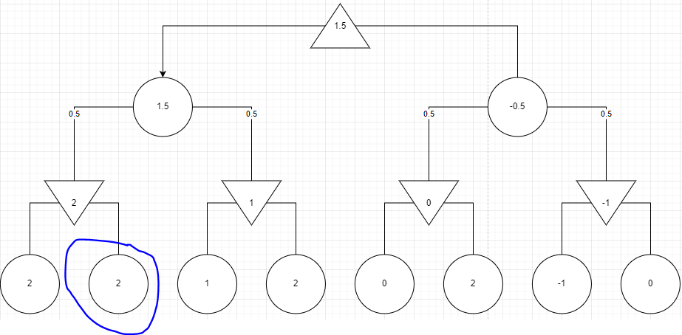

**Problem 5** For the following game tree, we have the prior information that all node values are integers that are ≥ 1 and ≤ 6. Find all values for X that require the algorithm to visit all leaf nodes of the game tree. We assume that the alpha-beta pruning performs a depth-first search that always generates the leftmost successor first.

X can have the values 2 - 6. As long as all of the leaf nodes are higher than the lowest possible value in the range (1), then when we get to the min nodes section, we will always have to account for the possibility of the leaf having a value of 1, and are forced to check the neighboring nodes.